Lab – 6

Web Application using Node-RED for Sensor Data Visualization

1. Aim
To create a Node-RED dashboard for displaying sensor data through a web interface.

2. Theory
Node-RED is a flow-based programming platform used for IoT applications.
Features:
- Visual programming
- Web dashboard support
- Easy integration with sensors and MQTT
Node-RED can display live sensor data using gauges and charts.

3. Apparatus / Requirements
- Computer system
- Node-RED
- Arduino with DHT sensor
- Internet/browser

4. Block Diagram
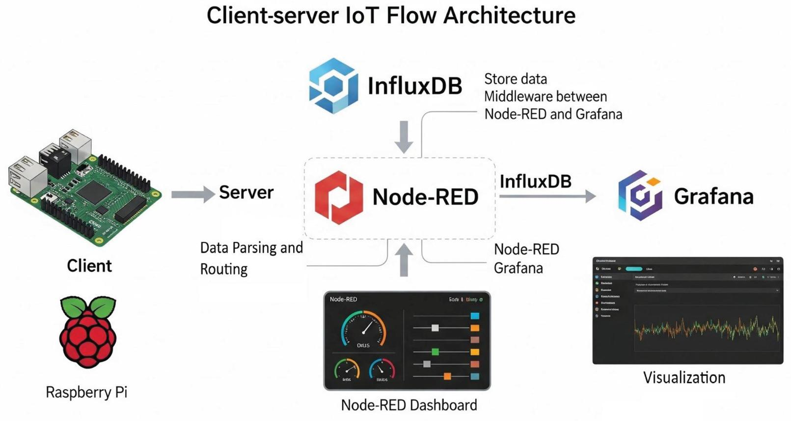
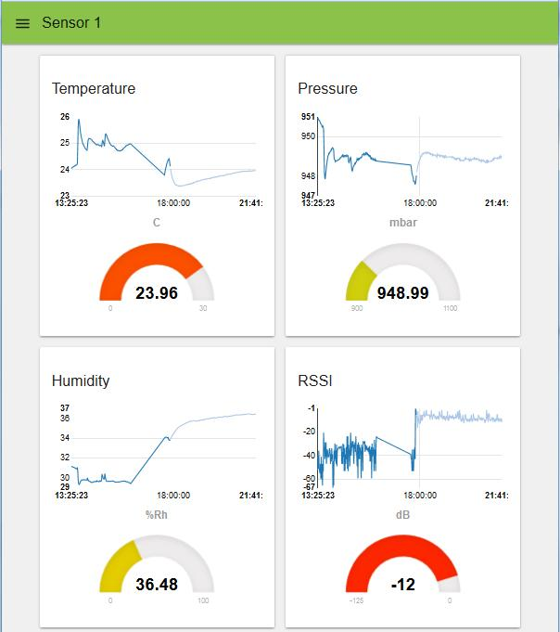
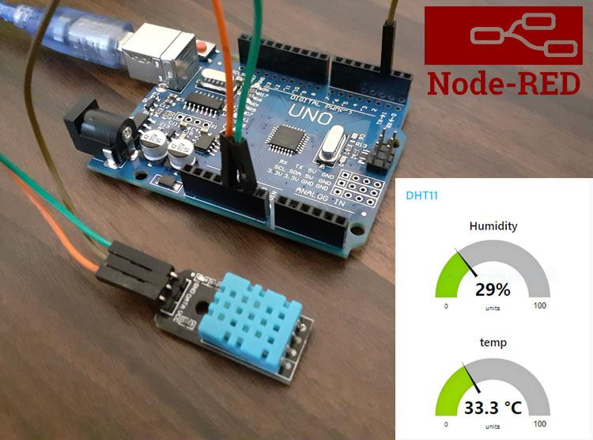

5. Procedure
- Install Node-RED
- Start Node-RED server
- Open dashboard in browser
- Add input and dashboard nodes
- Connect sensor data to dashboard
- Deploy the flow
- Observe live data visualization

6. Program / Code

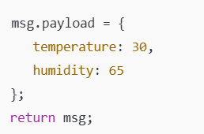

7. Observations / Readings
- Dashboard displayed live sensor values
- Data updated continuously
- Visualization improved readability

8. Result
A web dashboard was successfully created using Node-RED for sensor monitoring.

